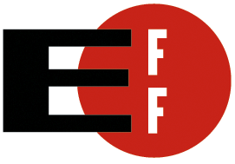  www.eff.org  (USA)  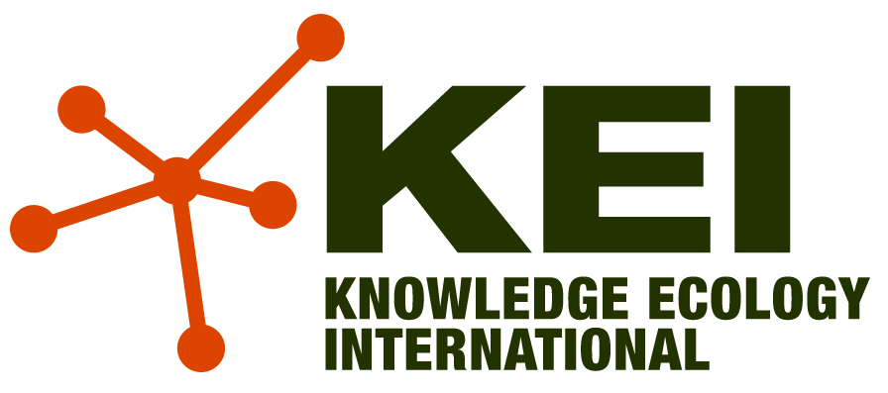  www.kei.org  (USA)    gpopai.usp.br  (Brazil)    publicknowledge.org  (USA)  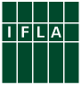  http://www.ifla.org/  (International-libraries)  http://www.eifl.net  (International- libraries - 60 countries)  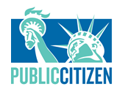citizen.org  (USA)  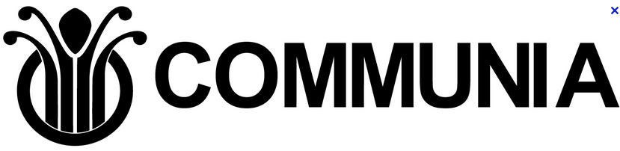  http://www.communia-association.org/  (Europe)  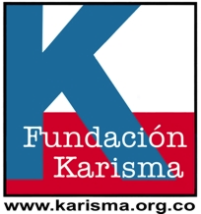  (Colombia)  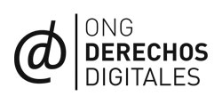  derechosdigitales.org  (Chile)  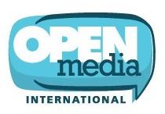  openmedia.ca  (Canada)  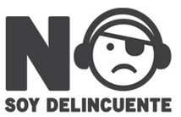  nosoydelincuente.pe  (Peru)  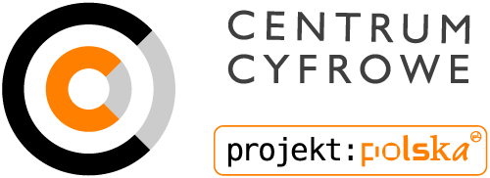  centrumcyfrowe.pl  (Poland)  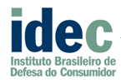  http://www.idec.org.br  (Brazil)  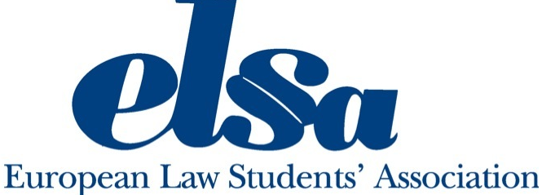  http://www.elsa.org/  (Europe)  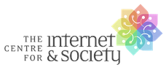  http://cis-india.org  (India)  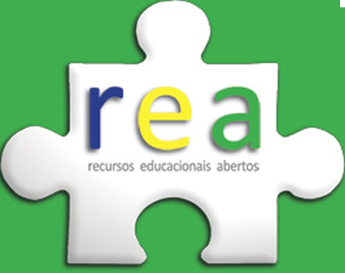  rea.net.br  (Brazil) | Civil Society statement on Exceptions and Limitations for Education  WIPO 24th SCCR  Geneva, 16-24, July 2012  On Monday, 16th July, 2012, the 24th meeting of the Word Intellectual Property Organization (WIPO) Standing Committee on Copyright and Related Rights (SCCR) opened in Geneva[1]. During the next ten days, the 185 WIPO Member States will discuss copyright flexibilities for visually impaired and print disabled people, libraries and archives, and for education and research[2].  Education should be accessible for all without barriers of space, time, or cost. Digital technologies, from the portable computer to mobile phones to tablets, are being introduced as crucial educational tools in countries ranging from South Korea to Nigeria, from Brazil to the USA. Educational materials and, therefore, its market, is increasingly becoming digital and policymakers must consider this trend when drafting copyright exceptions and limitations in a way that is appropriate for future generations and the digital age.  The increasing adoption of Information and Communication Technologies (ICTs) in the classroom and in libraries and archives has proven that teachers, learners, researchers, librarians and archivists need rights to access, use, remix, text-mine, exchange, and collaborate on educational materials.[3] Similar rights must be ensured beyond the classroom and library or archive, taking into account the growing importance of e-learning, online communication, and the increasing practice of exchanging educational and other information content across geographical and institutional borders.  The international copyright system has recognized the need for exceptions and limitations from its earliest days. Without these, the copyright system would not be able to achieve its fundamental purpose of encouraging creation and innovation for the benefit of all humankind.  To date however, international harmonization efforts have largely focused on one side of the equation: the rights of authors and rightholders. If balance is truly to be achieved, it is imperative that the rights of those who wish to use copyrighted works for education, research, and access to information be placed on an equal footing. Only this will allow the copyright system to serve the larger public interest.  Exceptions and limitations provide an opportunity to guarantee access to quality education: both through formal institutions and informal learning environments, and to all learners, including those with disabilities, in digital and non-digital formats. Libraries are an integral part of the education and research process and are often embedded within educational institutions. Exceptions and limitations enable libraries to carry out their public service role in supporting the needs of researchers, teachers, students and learners  For all these reasons, we urge WIPO Member countries to move forward in the process to adopt and support open-ended exceptions and limitations for education that are appropriate for the digital environment.  Specifically, we urge Member States at this 24th session of the SCCR of WIPO to engage in substantive discussions and to collaborate on working documents as a first step towards the adoption of an international legal instrument in this area.  Thus, Member States should consider the following recommendations as a way to promote the public interest:  1) No imposition of administrative, civil, or criminal liability for the circumvention of technological protection measures (TPMs) when done to access works in the public domain, openly-licensed works, or those that are permitted under national copyright exceptions and limitations or otherwise by national law. National laws must ensure that TPMs and contracts do not override existing exceptions and limitations or restrict access to material that is in the public domain[4]. Specifically, members shall provide for an express right for educational institutions, libraries and archives to be able to circumvent TPMs to enable their users, including students, teachers, researchers and librarians, to make lawful non-copyright infringing uses permitted under national law[5].  2) Ensure that the Three-Step test is not narrowly construed or applied to limitations and exceptions that operate outside this test in international trade agreements and conventions,[6] and that non-Three-Step exceptions continue to be available[7]. The Three-Step Test should be understood as to not preclude open-ended limitations and exceptions, such as those relating to fair practice or fair use. In an era of rapid technological development, purpose-based exceptions are often, by themselves, ill equipped for maintaining an appropriate balance. Exceptions must be future proofed to ensure that they remain meaningful.  3) Ensure that libraries and archives, educational, research and other public interest institutions are subject to limited remedies that have appropriate regard to their public interest function. In particular, ensure that these users are not subject to statutory or other punitive damages.  4) Allow the reproduction, digitization, translation, display, dissemination and distribution of out-of-print works for educational and research uses.  5) Specifically, in recognizing the shortcomings of Berne Appendix for Special Provisions for Developing Countries[8], we note the need to create new mechanisms to address, more effectively, the goal of facilitating affordable access to works in developing countries[9]. The compulsory licensing provisions in the Berne Appendix are complex, narrow, and not designed to address opportunities of the digital world. They are therefore widely considered unworkable and of little if any value to developing countries.  6) Promote the recognition of publicly funded works as public goods that the public should have a right to widely distribute, copy, and use.  7) Recognize that access to copyright protected works for education and research purposes must be facilitated by strengthening existing exceptions and limitations and broadening them to cover uses of digital works and uses outside of formal educational institutions.  8) Create mechanisms that support use of orphan works by the public, learners, educators, librarians and archivist. These could include copyright limitations and exceptions, limitations on remedies imposed against educational institutions and libraries, or non-compulsory, flexible licensing regimes.  9) Ensure the freedom of researchers to engage in large-scale text mining and other non-consumptive analytical uses of text and data for research.  10) Support access to copyright protected works for persons with disabilities through a robust exceptions and limitations framework that supports the importance of cross border exchanges of copies of works created under these exceptions. We oppose efforts to create new burdensome procedures.  11) Recognize that the creation of new kinds of rights, as has been proposed in the context of broadcaster protection, could undermine efforts to promote access to works.  12) Ensure that international exhaustion applies to the acquisition of works, both print and digital, needed by educational institutions, libraries and archives.[10].  [1] http://www.wipo.int/meetings/en/topic.jsp?group_id=62  [2] Research can also include many activities that do not demand the establishment of new facts or conclusions. It can be piecemeal, informal, exploratory, or confirmatory. It can in fact be undertaken for no purpose except personal interest. It is true that research can be for the purpose of reaching new conclusions, but this should be seen as only one, not the primary component of the definitional framework. http://www.michaelgeist.ca/content/view/6588/  [3] UNESCO recently—in a Declaration from June 2012—encouraged open licensing of educational materials produced with public funding.http://www.unesco.org/new/fileadmin/MULTIMEDIA/HQ/CI/CI/pdf/Events/Paris%20OER%20Declaration_01.pdf  [4] Rightholders are increasingly using TPMs together with contracts to control access to digital books and materials, precluding uses that involve no exclusive right of copyright (such as reading a book) and to restrict uses of digital works that would otherwise be permitted under national copyright exceptions and limitations, such as exhaustion. National laws and policies must ensure that TPMs and contracts cannot be used to re-write the traditional copyright balance. See, for instance EFF.org analysis of TPM risks at https://www.eff.org/node/58380, https://www.eff.org/deeplinks/2010/03/unintended-consequences-12-years-under-dmca and https://www.eff.org/issues/dmca-rulemaking  [5] For instance, New Zealand has adopted such provision, see: http://www.legislation.govt.nz/act/public/1994/0143/latest/DLM1705887.html “When rights of issuer of TPM work do not apply”  [6] http://www.ip.mpg.de/de/pub/aktuelles/declaration-threesteptest.cfm  [7] For example, for the Berne Convention, Articles 2bis, 10, 10bis, 11bis(2), 13, the Appendix on Special Provisions for Developing Countries; for the Rome Convention, Article 15; and for TRIPS Article 6, 40, 44.2 and 66.  [8] http://www.wipo.int/treaties/en/ip/berne/trtdocs_wo001.html  [9] This will promote access to knowledge for all, and to ensure that persons living in developing countries do not face barriers to education and development, or exclusions from access to cultural works.  [10] As allowed by TRIPS article 6 and WCT 6 (2) Nothing in this Treaty shall affect the freedom of Contracting Parties to determine the conditions, if any, under which the exhaustion of the right in paragraph (1) applies after the first sale or other transfer of ownership of the original or a copy of the work with the authorization of the author. http://www.wipo.int/treaties/en/ip/wct/trtdocs_wo033.html#P62_6959

